**EFS Assignment**

A cloud engineer wants to evaluate Amazon Elastic File System (EFS) as a scalable, shared storage solution for multiple EC2 instances. The objective is to verify whether different EC2 instances can simultaneously access and modify files stored in an EFS mount point, demonstrating its suitability for distributed applications, containerized workloads, and shared data environments.

To conduct this experiment, the engineer will:

Create an EFS file system and configure it within a specific AWS region.

Attach and mount the EFS volume on multiple EC2 instances.

Create and modify files from one EC2 instance.

Access the same files from another EC2 instance to confirm data consistency.

* Create a file system with in a single AZ. Since my instances are in ap-south-1b, I will be creating the EFS on the same AZ  
  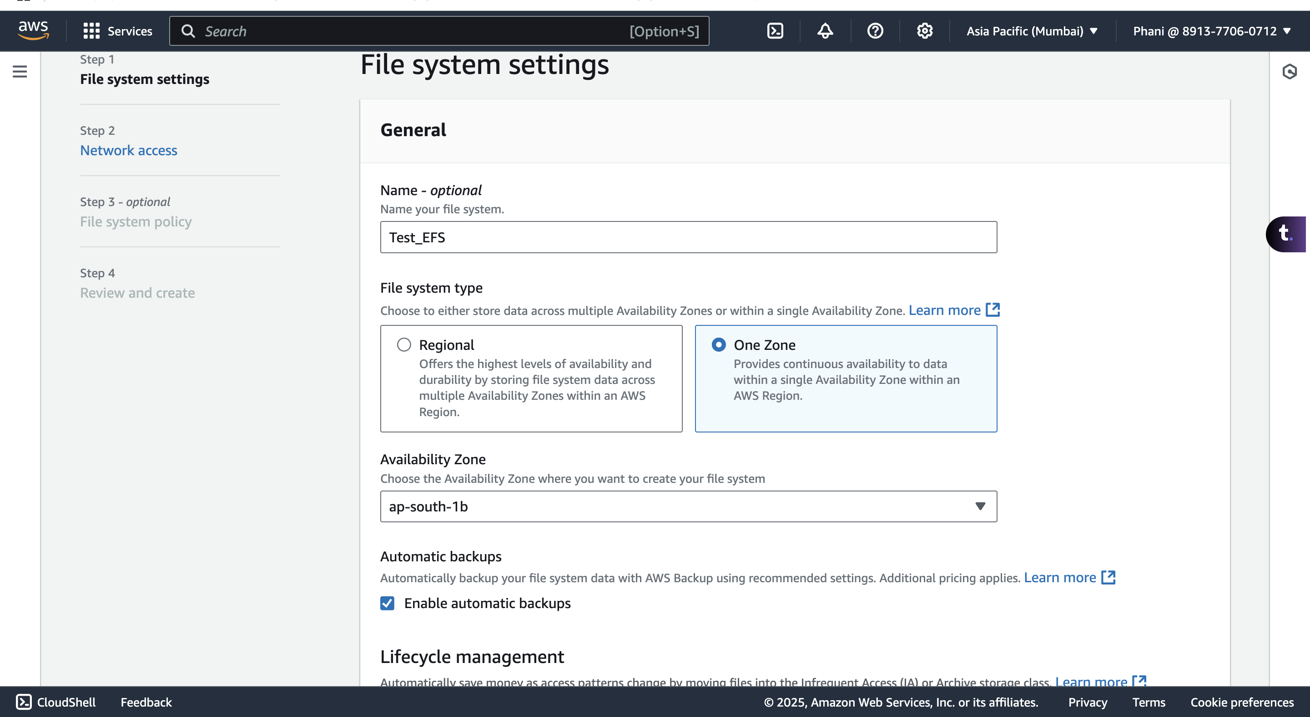
* Create a sg with ssh inbound rule and add it to the EFS  
  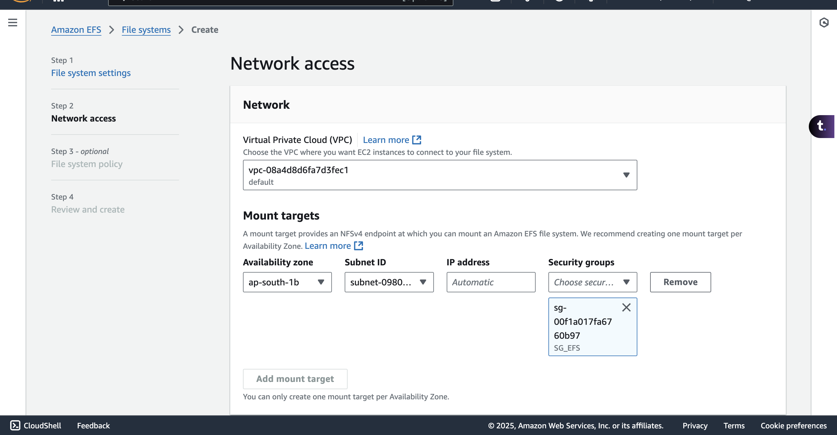  
    
  A screenshot of a computer

  AI-generated content may be incorrect.

* Attach the EFS   
  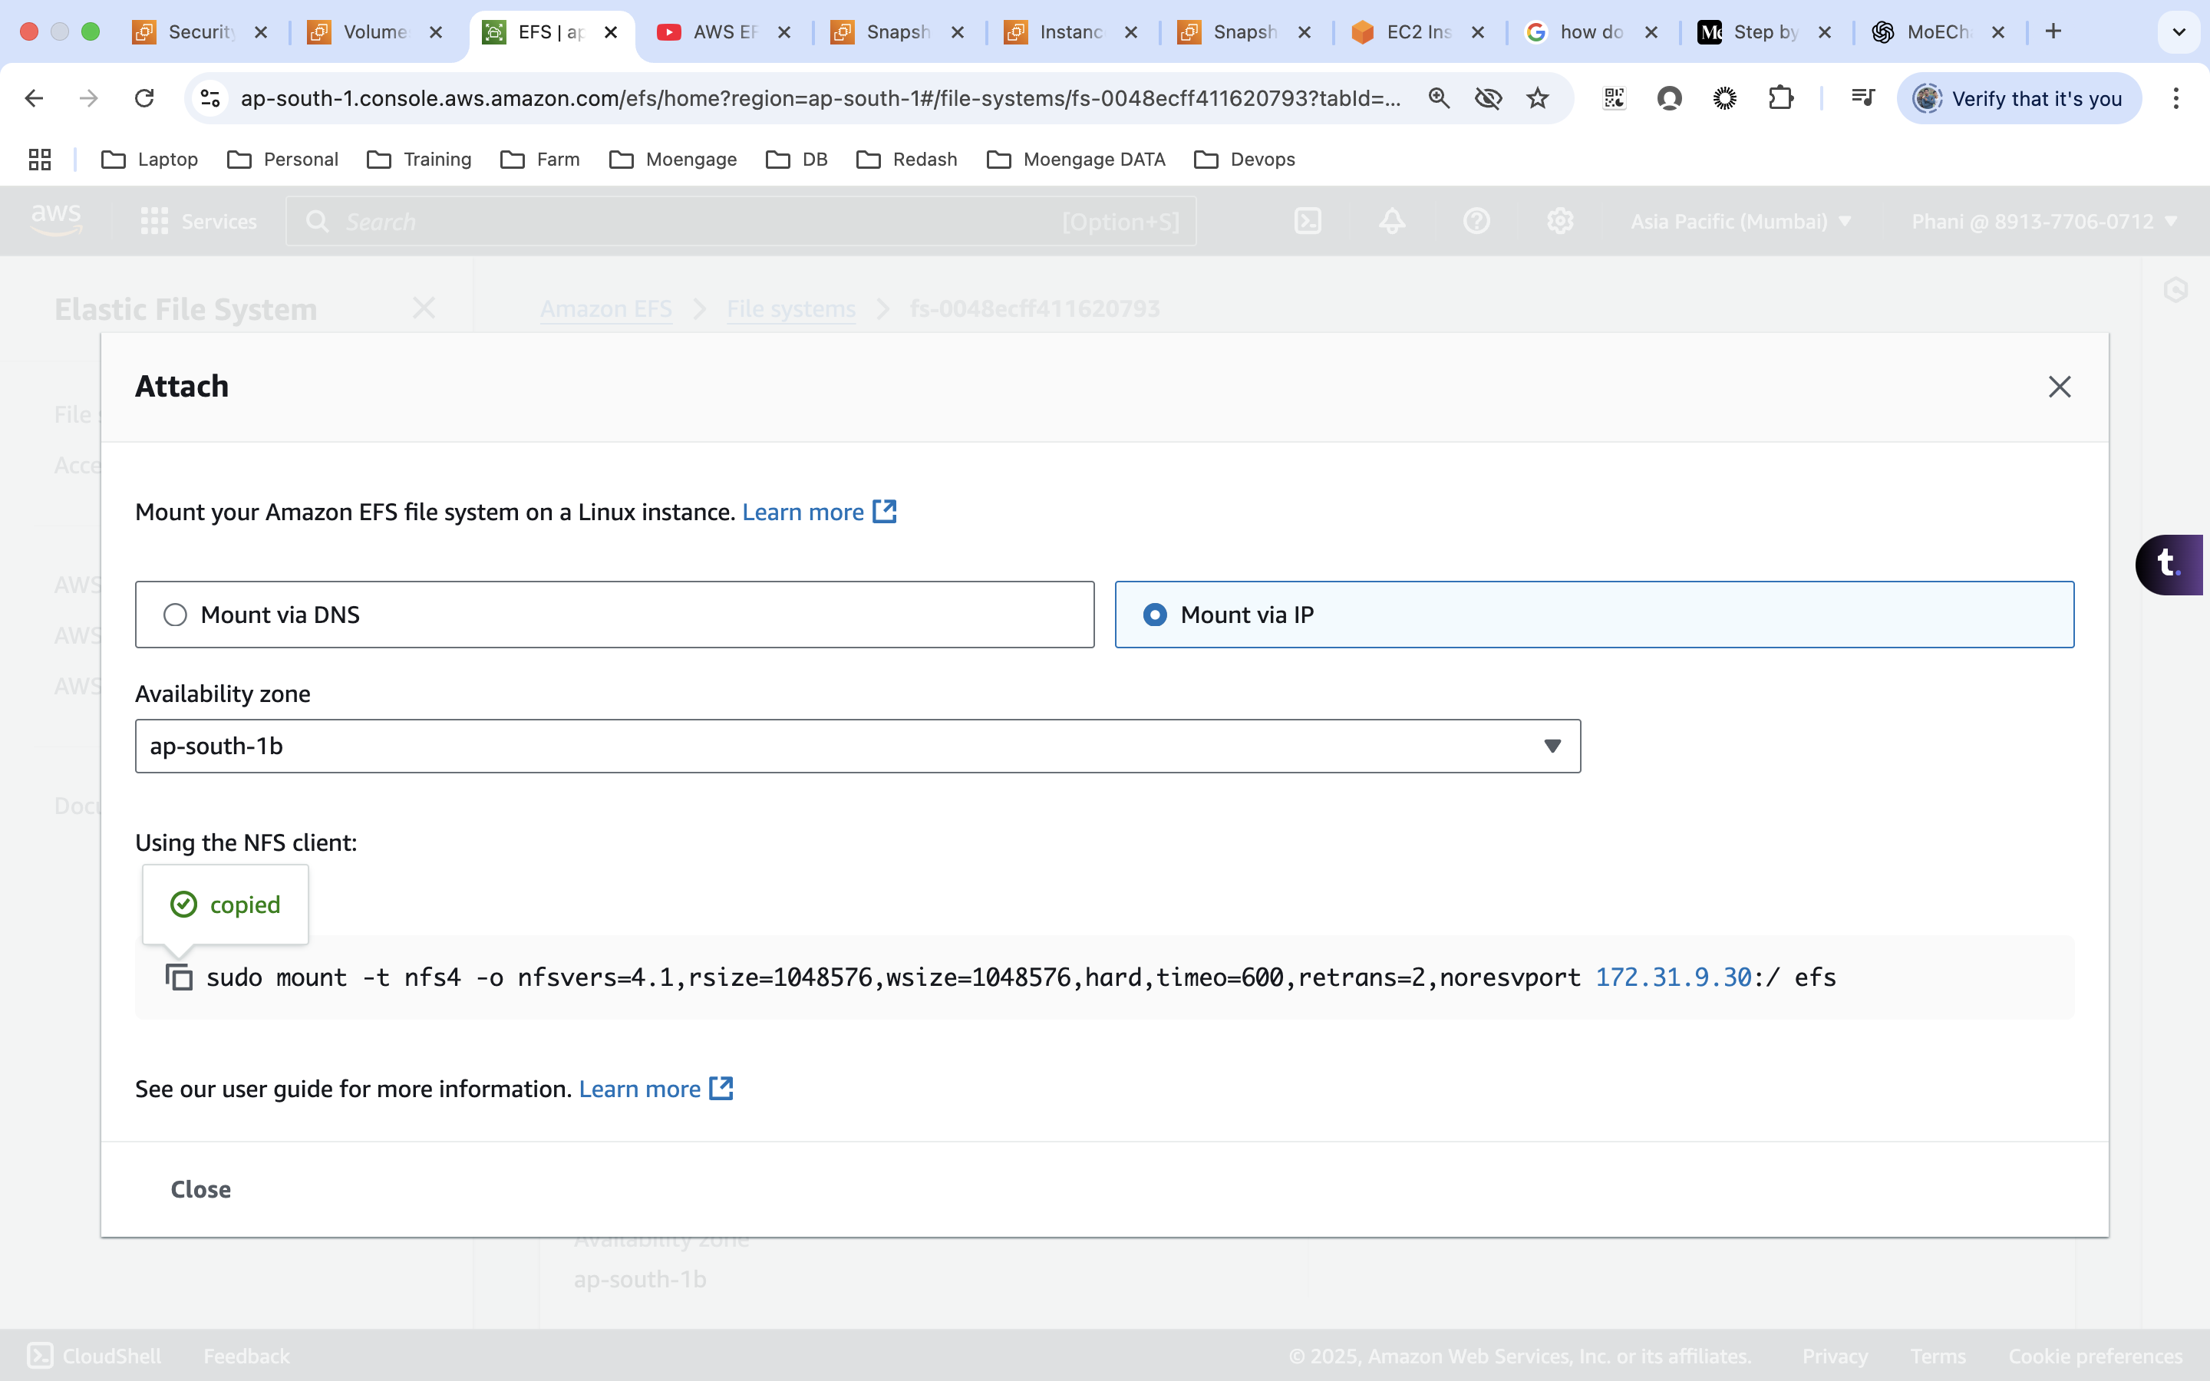
* Spin-up 2 instance(Make sure we have the NFS and SSH inbound role)  
  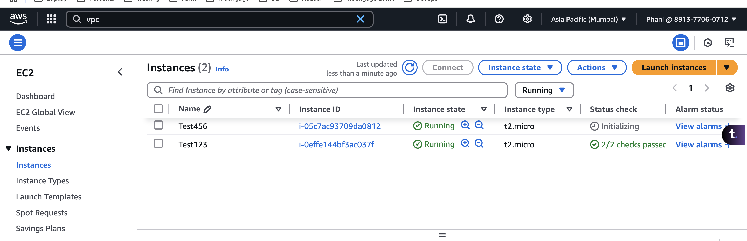
* Connect to one of the instance and create a directory to mount the EFS.
* run the below command  
  A screenshot of a computer

  AI-generated content may be incorrect.
* A screenshot of a computer

  AI-generated content may be incorrect.

